Lab 11 Configuring IPv6 Addressing

## Topology

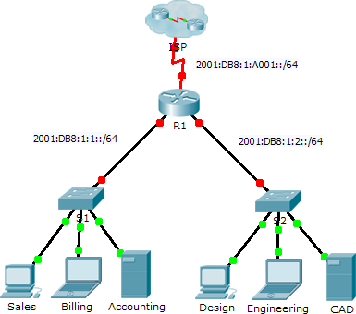

**Addressing Table**

|  |  |  |  |
| --- | --- | --- | --- |
| **Device** | **Interface** | **IPv6 Address/Prefix** | **Default Gateway** |
| R1 | G0/0 | 2001:DB8:1:1::1/64 | N/A |
| G0/1 | 2001:DB8:1:2::1/64 | N/A |
| S0/0/0 | 2001:DB8:1:A001::2/64 | N/A |
| Link-local | FE80::1 | N/A |
| Sales | NIC | 2001:DB8:1:1::2/64 | FE80::1 |
| Billing | NIC | 2001:DB8:1:1::3/64 | FE80::1 |
| Accounting | NIC | 2001:DB8:1:1::4/64 | FE80::1 |
| Design | NIC | 2001:DB8:1:2::2/64 | FE80::1 |
| Engineering | NIC | 2001:DB8:1:2::3/64 | FE80::1 |
| CAD | NIC | 2001:DB8:1:2::4/64 | FE80::1 |

## Objectives

**Part 1: Configure IPv6 Addressing on the Router Part 2: Configure IPv6 Addressing on Servers Part 3: Configure IPv6 Addressing on Clients Part 4: Test and Verify Network Connectivity**

## Background

In this activity, you will practice configuring IPv6 addresses on a router, servers, and clients. You will also practice verifying your IPv6 addressing implementation.

# Part 1: Configure IPv6 Addressing on the Router

### Step 1: Enable the router to forward IPv6 packets.

a. Enter the ipv6 unicast-routing global configuration command. This command must be configured to enable the router to forward IPv6 packets. This command will be discussed in a later semester.

R1(config)# ipv6 unicast-routing

### Step 2: Configure IPv6 addressing on GigabitEthernet0/0.

1. Click **R1** and then the **CLI** tab. Press **Enter**.
2. Enter privileged EXEC mode.
3. Enter the commands necessary to transition to interface configuration mode for GigabitEthernet0/0.
4. Configure the IPv6 address with the following command:

R1(config-if)# **ipv6 address 2001:DB8:1:1::1/64**

1. Configure the link-local IPv6 address with the following command:

R1(config-if)# **ipv6 address FE80::1 link-local**

1. Activate the interface.

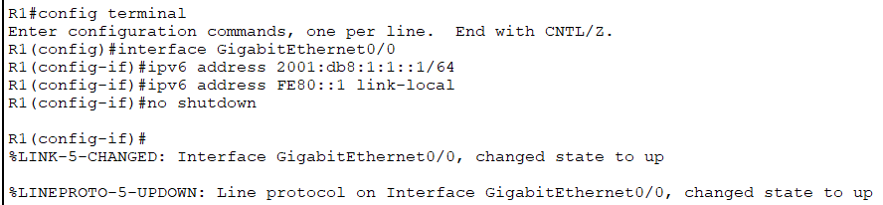

### Step 3: Configure IPv6 addressing on GigabitEthernet0/1.

1. Enter the commands necessary to transition to interface configuration mode for GigabitEthernet0/1.
2. Refer to the **Addressing Table** to obtain the correct IPv6 address.
3. Configure the IPv6 address, the link-local address and activate the interface.

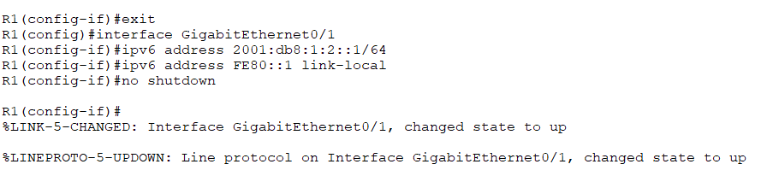

### Step 4: Configure IPv6 addressing on Serial0/0/0.

1. Enter the commands necessary to transition to interface configuration mode for Serial0/0/0.
2. Refer to the **Addressing Table** to obtain the correct IPv6 address.
3. Configure the IPv6 address, the link-local and activate the interface.

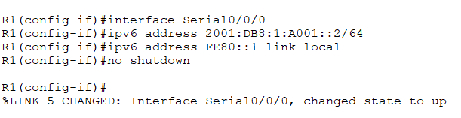

# Part 2: Configure IPv6 Addressing on the Servers

### Step 1: Configure IPv6 addressing on the Accounting Server.

1. Click **Accounting** and click the **Desktop** tab > **IP Configuration**.
2. Set the **IPv6 Address** to **2001:DB8:1:1::4** with a prefix of **/64**.
3. Set the **IPv6 Gateway** to the link-local address, **FE80::1**.

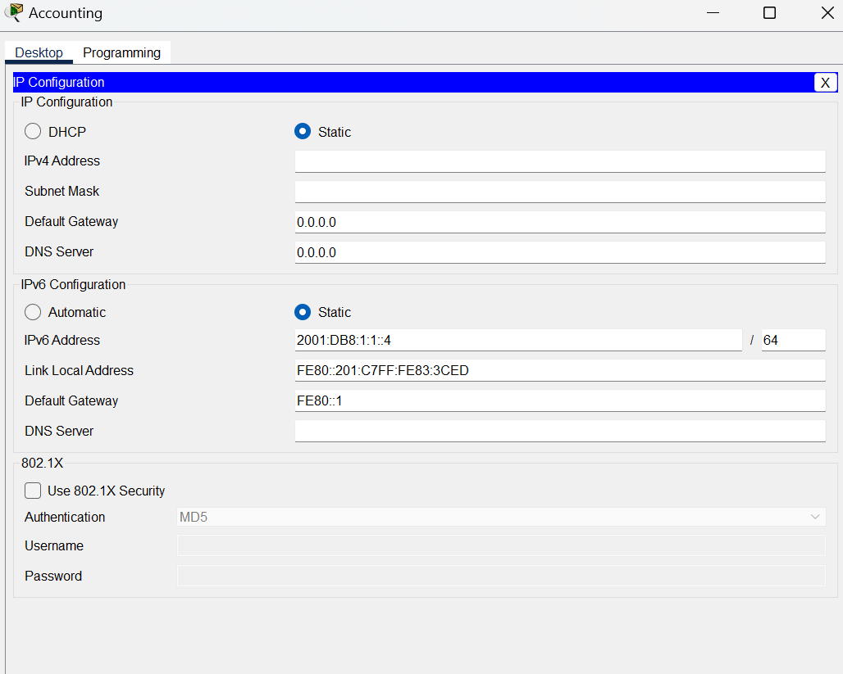

### Step 2: Configure IPv6 addressing on the CAD Server.

Repeat Steps 1a to 1c for the **CAD** server. Refer to the **Addressing Table** for the IPv6 address.

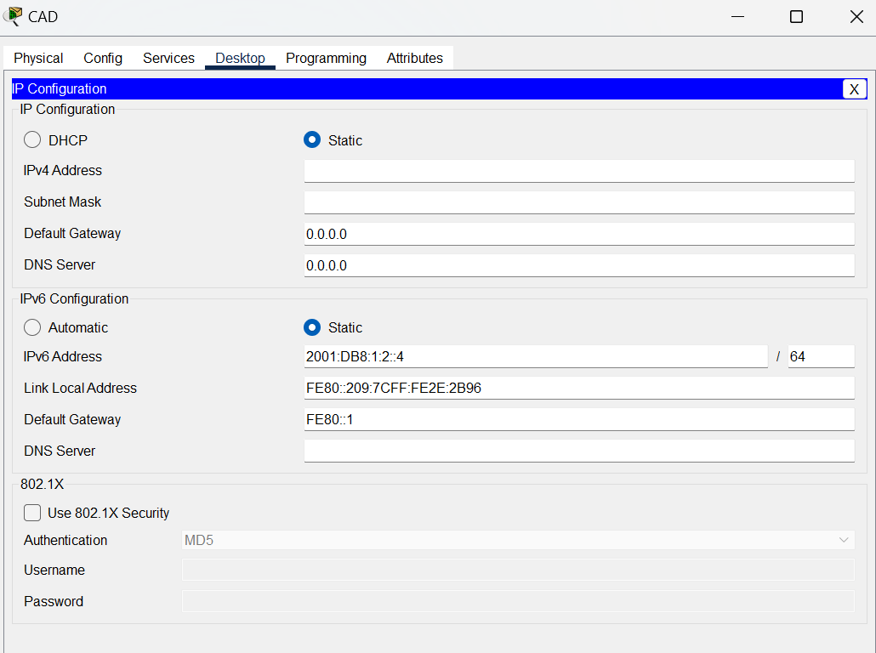

# Part 3: Configure IPv6 Addressing on the Clients

### Step 1: Configure IPv6 addressing on the Sales and Billing Clients.

1. Click **Billing** and then select the **Desktop** tab followed by **IP Configuration**.
2. Set the **IPv6 Address** to **2001:DB8:1:1::3** with a prefix of **/64**.
3. Set the **IPv6 Gateway** to the link-local address, **FE80::1**.
4. Repeat Steps 1a through 1c for **Sales**. Refer to the **Addressing Table** for the IPv6 address.

### Step 2: Configure IPv6 Addressing on the Engineering and Design Clients.

1. Click **Engineering** and then select the **Desktop** tab followed by **IP Configuration**.
2. Set the **IPv6 Address** to **2001:DB8:1:2::3** with a prefix of **/64**.
3. Set the **IPv6 Gateway** to the link-local address, **FE80::1**.
4. Repeat Steps 1a through 1c for **Design**. Refer to the **Addressing Table** for the IPv6 address.

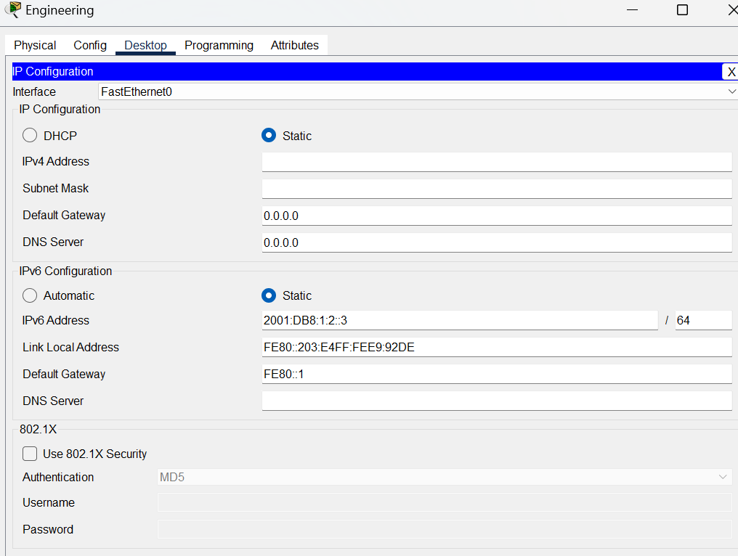

**This topology summarizes that all the configurations of the Ipv6 addresses have been completed for all the devices present in network.**

# Part 4: Test and Verify Network Connectivity

### Step 1: Open the server web pages from the clients.

1. Click **Sales** and click the **Desktop** tab. Close the **IP Configuration** window, if necessary.
2. Click **Web Browser**. Enter **2001:DB8:1:1::4** in the URL box and click **Go**. The **Accounting** website should appear.
3. Enter **2001:DB8:1:2::4** in the URL box and click **Go**. The **CAD** website should appear.
4. Repeat steps 1a through 1d for the rest of the clients.

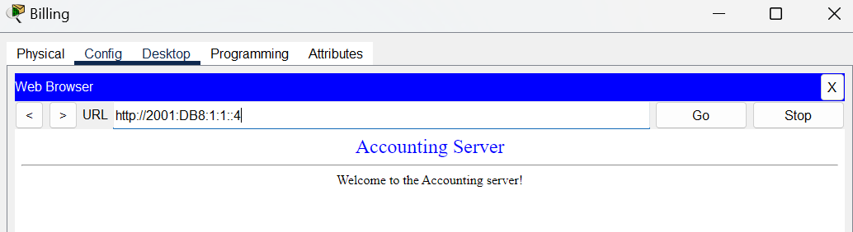

### Step 2: Ping the ISP.

1. Open any client computer configuration window by clicking the icon.
2. Click the **Desktop** tab > **Command Prompt**.
3. Test connectivity to the ISP by entering the following command:

#### PC> ping 2001:DB8:1:A001::1

1. Repeat the **ping** command with other clients until full connectivity is verified.

